[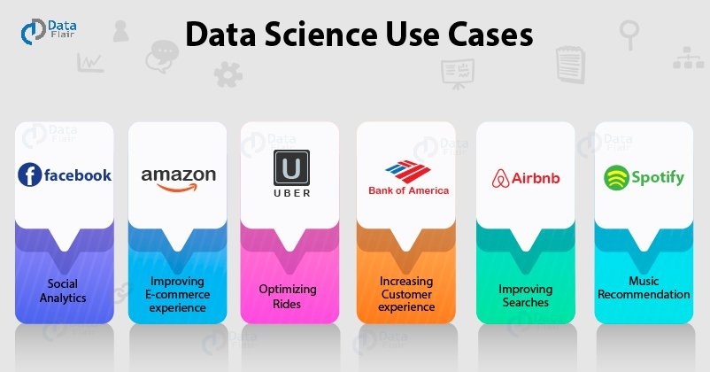](https://data-flair.training/blogs/wp-content/uploads/sites/2/2019/04/data-science-use-cases.jpg)

Why We Need Data Science?

Data Science has brought another industrial revolution to the world. Every industry in this world requires data. With the advancements in computational capabilities, it is possible for the companies to analyze large scale data and understand insights from this massive horde of information.

Furthermore, with data science, industries can take proper data-driven decisions. In this article, we will see how industries have used data to shape their customer experiences.

Data Science Use Cases

Here is the list of top 6 data science use cases that you must know. Big companies are using data science for different purposes. Let’s start with the most demanding one that is Facebook –

1. Facebook – Using Data to Revolutionize Social Networking & Advertising

Facebook is a social-media leader of the world today. With millions of users around the world, Facebook utilizes a large scale quantitative research through data science to gain insights about the social interactions of the people.

Facebook has become a hub of innovation where it has been using advanced techniques in data science to study user behavior and gain insights to improve their product. Facebook makes use of advanced technology in data science called [**deep learning**](https://data-flair.training/blogs/deep-learning-tutorial/).

Using deep learning, Facebook makes use of facial recognition and text analysis. In facial recognition, Facebook uses powerful neural networks to classify faces in the photographs. It uses its own text understanding engine called “DeepText” to understand user sentences.

It also uses Deep Text to understand people’s interest and aligning photographs with texts.

However, more than being a social media platform, Facebook is more of an advertisement corporation. It uses deep learning for targeted advertising. Using this, it decides what kind of advertisements the users should view.

It uses the insights gained from the data to cluster users based on their preferences and provides them with the advertisements that appeal to them.

2. Amazon – Transforming E-commerce with Data Science

Since its inception, Amazon has been working hard to make itself a customer-centric platform. Amazon heavily relies on [**predictive analytics**](https://www.ibm.com/in-en/analytics/predictive-analytics) to increase customer satisfaction. It does so through a personalized recommendation system.

This recommendation system is a hybrid type that also involves collaborative filtering which is comprehensive in nature. Amazon analyzes the historical purchases of the user to recommend more products.

This also comes through the suggestions that are drawn from the other users who use similar products or provide similar ratings.

[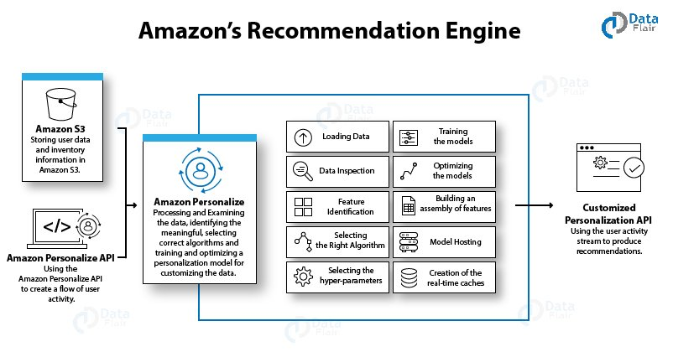](https://data-flair.training/blogs/wp-content/uploads/sites/2/2019/04/Amazon-Recommendation-Engine.jpg)

Amazon has an anticipatory shipping model that uses big data for predicting the products that are most likely to be purchased by its users. It analyzes the pattern of your purchases and sends products to your nearest warehouse which you may utilize in the future.

Amazon also optimizes the prices on its websites by keeping in mind various parameters like the user activity, order history, prices offered by the competitors, product availability, etc. Using this method, Amazon provides discounts on popular items and earns profits on less popular items.

Another area where every e-commerce platform is addressing is **Fraud Detection**. Amazon has its own novel ways and algorithms to detect fraud sellers and fraudulent purchases.

Other than online platforms, Amazon has been optimizing the packaging of products in warehouses and increasing the efficiency of packaging lines through the data collected from the workers.

3. Uber – Using Data to Make Rides Better

Next in data science use cases is Uber. Uber is a popular smartphone application that allows you to book a cab. Uber makes extensive use of [**Big Data**](https://data-flair.training/blogs/what-is-big-data/). After all, Uber has to maintain a large database of drivers, customers, and several other records.

It is therefore, rooted in Big Data and makes use of it to derive insights and provide the best services to its users. Uber shares the big data principle with crowdsourcing. That is, registered drivers in the area can help anyone who wants to go somewhere.

As mentioned above, Uber contains a database of drivers. Therefore, whenever you hail for a cab, Uber matches your profile with the most suitable driver. What differentiates Uber from other cab companies is that Uber charges you based on the time it takes to cover the distance and not the distance itself.

It calculates the time taken through various algorithms that also make use of data related to traffic density and weather conditions.

Uber makes the best use of data science to calculate its surge pricing. When there are less drivers available to more riders, the price of the ride goes up. This happens only during the scarcity of drivers in any given area.

However, if the demand for Uber rides is less, then Uber charges a lower rate. This dynamic pricing is rooted in Big Data and makes excellent usage of data science to calculate the fares based on the parameters.

4. Bank of America – Using Data to Leverage Customer Experience

10 years ago, Bank of America was one of the first financial companies to provide mobile banking to its customers. Recently, BoA launched Erica which is their first virtual financial assistant. It is considered as the world’s finest innovation in finance domain.

Currently, Erica is serving as a customer advisor to more than 45 million users around the world. Erica also makes use of Speech Recognition to take customer inputs, which is a technological advancement in the field of Data Science.

Furthermore, several other banks like BoA are making use of **Data Science and predictive analytics**. Using data science, banking industries are able to detect frauds in payments and customer information. It also prevents frauds regarding insurances, credit cards, and accounting.

In order to minimize the losses, a bank needs to detect fraud sooner. In order to carry this out, banks employ data scientists to use their quantitative knowledge where they apply algorithms like association, clustering, forecasting, and classification.

**Risk modeling** is another important area that is supervised by the banks to regulate financial activities. Using Machine Learning, banks are able to minimize risk modeling.

Through analytical solutions, banks can make data-driven decisions that are based on transparency and risk analysis. Furthermore, Bank of America detected the high-risk accounts using this technology of big data.

Various banks like BoA are understanding their customers through an intelligent customer segmentation approach. Through various data-mining techniques, banks are able to segment their customers in the high-value and low-value segments.

There are various techniques that a data scientist makes use of such as clustering, logistic regression, decision trees to help the banks to understand the Customer Lifetime Value (CLV) and take group them in the appropriate segments.

5. Airbnb – Using Data to Make Stays More Comfortable

Airbnb is an international hospitality company that allows you to host accommodations as well as find them through its mobile app and website. It is a data-centric industry. It contains a massive big data of customer and host information, homestays and lodge records, as well as website traffic.

Data Science plays a pivotal role in this company. It uses data to provide better search results to its customers. It makes use of demographic analytics to analyze bounce rates from their websites.

In 2014, Airbnb found out that users from certain countries would click the neighborhood link, browse the page and photos and not make any booking.

In order to mitigate this issue, Airbnb released a different version for the users from those countries and replaced neighborhood links with the top travel destinations. This saw a 10% improvement in the lift rate for those users.

Furthermore, Airbnb makes use of knowledge graphs where the user’s preferences are matched with the various parameters to provide ideal lodgings and localities. It has also optimized its search engine to provide better results to the customers and find compatible hosts.

6. Spotify – Revolutionizing Music Streaming

Next in Data Science Use Cases is Spotify. It is an online music streaming giant that uses Data Science for providing personalized music recommendations. With over 100 million users, Spotify deals with a massive amount of big data.

It uses the 600 GBs of daily data generated by the users to build its algorithms to boost user experience. Spotify is a data-driven company that leverages big data to provide personalized playlists to its users.

Spotify has also brought several analytical features for its artists through the introduction of Spotify for Artists application. This allows the artists and managers to analyze their streams, fan approval and the hits they are generating through several of Spotify’s playlists.

In the year 2017, Spotify used data science to gain insights about which universities had the highest percentage of party playlists and which ones spent the most time on it. It publishes its findings on their page “Spotify Insights” to provide information about the ongoing trends in the music.

Also, in the same year, Spotify purchased Niland, which is an API based product that uses machine learning to provide better searches and recommendations to its users.

Furthermore, Spotify analyzed the listening habits of the users to predict the Grammy Award Winners. In the year 2013, Spotify made 4 correct predictions out of 6.